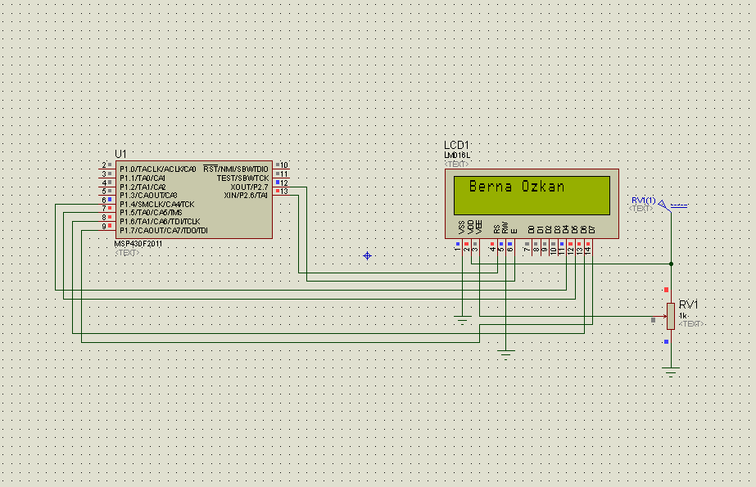

#include "io430.h"

#include "lcdFonksiyonlar.h"

void main( void )

{

WDTCTL = WDTPW + WDTHOLD;

P1DIR = 0xF0;

P2DIR = 0xFF;

P2SEL = 0x00;

lcdHazirla();

lcdBekle(20);

lcdHucreyeGit(2, 2);

lcdYaziYaz(" ");

lcdHucreyeGit(1, 2);

lcdYaziYaz("Berna Ozkan");

while(1);

}